Room Dimensions:

Main Rooms:

Width = 321 inches

Length = 378 inches

Height = 114 inches

Side Rooms:

Width = 120 inches

Length = 132 inches

Height = 96 inches

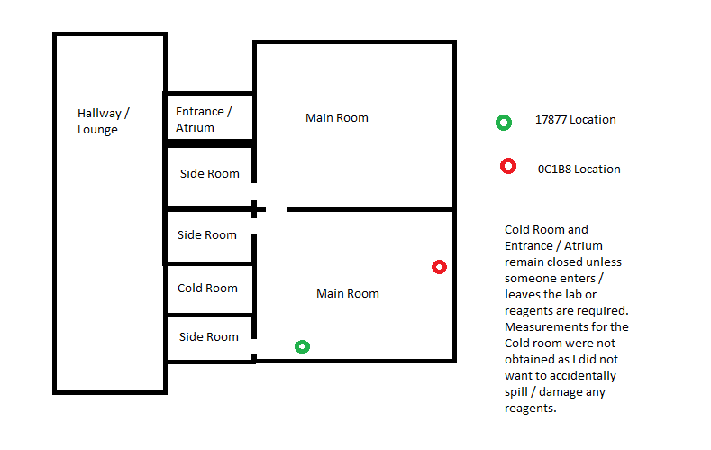

Layout:

Additional Notes:

0C1B8 is right next to a computer, so the values for this sensor will likely be a little bit higher than for the other. Additionally, more people spend time in the upper main room (where no sensors were placed) than in the lower main room. Usually, there are no more than 3 people in any given main room. I would say that there are usually 5 - 6 people in the lab. There is never more than 10 people in the lab.

I went to grab the sensors at around 6pm on the 15th. I spent some time in the lab measuring the dimensions and looking for equipment I needed to upload the data. There is a spike at the end of each sensor data, however there is a disparity between the spikes as OC1B8 was much closer to me while I was on the computer. However, I was not on the computer that long, so I don’t think it will be that big of a deal.

If we need more data collected, I can do that, it would just be better to know sooner rather than later